New tiles for BB2 will have ambient animations, and animations when the player hits them. The basic block is a solid color block, usually white. Different colors will be used depending on the zone. As an example, Zone 1 would be white, zone 2 would be yellow.

Colors can be used to change the meaning of the block, or theme of the level.

In BB1, the block color indicated what type of block it was. In BB2 we don't have to rely on the block color anymore, and can make use of block dressings instead. This would free us to use color slots for other things.

Example basic blocks with colors:



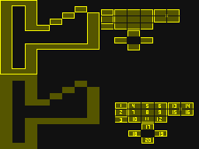

Ideas for what the blocks might look like put together to form level sections:

